Feb 12, 3:38pm

Leo Da Lion

Ok so meeting around 4:30?

Rizwan P

I don't even get out of class til 530. What r we doing meeting up to do?

Nathan Plotts

Server design/what language we're going to use

Steven Whaley

Also talk about getting started on geogram. Cycle 1goals etc

Rizwan P

How long do u think this meeting will last?

Nathan Plotts

Leo is there another time you can meet?

Leo Da Lion

Tomorrow during the day or maybe later tonight. I might not go home if there happens to be a lot of snow and stuff. But I'm not sure about that

Rizwan P

I'd be willing to meet tomorrow during the day I am out of class at 1215

Nathan Plotts

I'm free from 12:15-3:30 or after 4:45

Rizwan P

I'd really prefer that

Leo Da Lion

Yea that works with me too just up to everyone else also

Feb 12, 6:32pm

Nathan Plotts

Is everyone free around 10 or 11 tomorrow (I know you are)? Does anyone know of an alternative spot to meet in case we can't get into Shelby?

Rizwan P

My clubhouse. I’m not gonna have a car tomorrow either so that's probably as far as I can get

Leo Da Lion

My house. We can use the collaboration website I was .. Video,chat, and draw board

Feb 12, 9:15pm

Nathan Plotts

Rizwan I can give you a ride

Feb 12, 9:35pm

Rizwan P

That works where r we meeting and is everyone gonna be able to make it?

Nathan Plotts

I assume we'll try Shelby first

Rizwan P

Was it open last time?

Nathan Plotts

Nope, but we still managed to get in so that's what I'm hoping for

Rizwan P

Ok

Feb 13, 9:24am

Nathan Plotts

Everybody is still planning on meeting this morning right?

Feb 13, 9:47am

Steven Whaley

Sure but where? Can we get in to Shelby?

Charles Baker

I can still meet. I could go check Shelby if you want, before everyone drives there

Feb 13, 10:01am

Charles Baker

About to head there

Feb 13, 10:09am

Nathan Plotts

Bang on doors and stuff if you see someone, and check all the doors to see if one didn't close all the way

Charles Baker

I have card access

Nathan Plotts

So you're in?

Charles Baker

Yeah

Feb 13, 10:38am

Leo Da Lion

Nathan ur giving Rizwan a ride?

Nathan Plotts

Yea. We’re heading over right now

Leo Da Lion

Ok

Feb 13, 11:02am

Steven Whaley

I'll be there in a few

Denney Burkholder

Leavin my appt now

Feb 13, 9:02pm

Leo Da Lion

Oh yea what's due Monday?

Nathan Plotts

The status report

Leo Da Lion

So we need all user stories planned out?

Nathan Plotts

Pretty much yea, but we're waiting for him to email us back

Feb 16, 2:11pm

Leo Da Lion

Did chapman email you back? And what do we need to submit tomo?

Feb 16, 3:10pm

Leo Da Lion

Also I'm in the lab if anyone wants to come work on it

Feb 16, 3:39pm

Leo Da Lion

Also if were not meeting just have your part of the status report done and whatever you've worked on by 3PM tomorrow

Feb 16, 5:52pm

Nathan Plotts

Nope, never emailed me back

Leo Da Lion

Ok we need to get working on this

Feb 16, 6:25pm

Leo Da Lion

Who can meet tonight?

Nathan Plotts

I can't, I've got homework due at midnight

Feb 16, 6:30pm

Denney Burkholder

Yeah im doing the same for umphress!

Feb 16, 9:29pm

Leo Da Lion

Does that first assignment really take that long?

Nathan Plotts

I started at 6 and I'm still working on it. He didn't really explain well what he wants

Leo Da Lion

Ok well we have a status report that's due tomorrow 5pm and whenever you guys want to start working on it we can

Nathan Plotts

There's not much to work on other than fill in hours once Chapman emails us back. Also, if he doesn't we can just go with the user stories we have and fill in hours based off that

Leo Da Lion

So we aren't going to plan out each user story?

Nathan Plotts

We do need to, but it's also not required for the status report

Leo Da Lion

The first page of the status report has user story and estimated hours

Nathan Plotts

Oh yea, forgot about that. Thought you were talking about fleshing out each user story to actual requirements. If people are free to meet up tomorrow then we can do that

Feb 16, 9:55pm

Leo Da Lion

Ok well if people can have their part of the Go server done by Tuesday night

Feb 17, 10:20am

Leo Da Lion

Can everyone email me their time sheet part of the status report

Feb 17, 10:45am

Nathan Plotts

Remember that we met for 1 hour Wednesday night (except for rizwan) and then met for 5 hours on Thursday (11-5 minus messing around time)

Leo Da Lion

Yea put 4 hours for Thursday, I'll also be in the lab till my 1 o'clock class

Feb 17, 10:56am

Nathan Plotts

I'll only be free to meet after 1

Leo Da Lion

Ok well I'll be here around 1:30 again

Nathan Plotts

Kk, I'll probably just head over there after I get off work. Chapman just emailed me back, "These look good at this stage. Thanks."

Feb 17, 11:09am

Nathan Plotts

These reports go Monday to Sunday night for hours right? Or is that reasonable at least?

Rizwan P

I think it's Tuesday to Monday

Leo Da Lion

Yea it's Tuesday to today

Nathan Plotts

Then how do I include the work I'm doing right now? Lol

Leo Da Lion

You can add it to Monday

Nathan Plotts

You mean Tuesday?

Leo Da Lion

No Monday today. You can add stuff to today's date

Feb 17, 11:22am

Leo Da Lion

Rizwan you didn't come Wednesday but you put hours there...

Nathan Plotts

I'll email my stuff once I get off work and stop working on it. Is everyone free from 3-3:30 tomorrow? We need to set up a meeting time to go over user stories with Chapman (as our customer)

Charles Baker

Sure

Feb 17, 12:26pm

Nathan Plotts

Sent Chapman an email asking if he was free tomorrow at 3 and if not when he's free on Wednesday

Feb 17, 12:36pm

Rizwan P

Hey just so everyone knows I am dropping senior design

Charles Baker

Enjoy your semester

Feb 17, 12:47pm

Nathan Plotts

Alright, it's been good working with you. Thanks for letting us know

Feb 17, 1:10pm

Rizwan P

It was fun sorry I'm leaving all of u like this

Feb 17, 2:25pm

Nathan Plotts

Hurry up and send in your hours, we gotta get it compiled

Feb 17, 4:26pm

Leo Da Lion

Nathan can you do the devices for go?

Nathan Plotts

Yea I should be able to

Leo Da Lion

Ok can you have it ready by tomorrow night? And Denney have the web server ready by tomorrow night

Nathan Plotts

Haha, we'll see

Leo Da Lion

Can you or can you not? Cause I'll do it if you can't have it done

Nathan Plotts

I'd like to give it a shot but I can't guarantee it'll be totally done

Feb 17, 4:43pm

Leo Da Lion

Ok even if you don't have it totally done as long as there are parts we can work off of

Feb 17, 4:54pm

Denney Burkholder

Yeah what time do yall wanna meet up tomo

Feb 18, 12:04am

Nathan Plotts

Leo have you committed any server code yet?

Feb 18, 9:43am

Leo Da Lion

No not yet

Leo Da Lion

Like the main server or the websocket part

Nathan Plotts

Any, it'll help give me a better idea of what all I need to encompass in the laptop file

Feb 18, 2:08pm

Nathan Plotts

Does every go file need a main?

Feb 18, 2:41pm

Leo Da Lion

Negative

Feb 18, 3:28pm

Leo Da Lion

Meeting 5:30

Feb 18, 5:24pm

Nathan Plotts

Gonna be a couple minutes late, just got home and am leaving again

Denney Burkholder

Im just now leaving too wasnt paying attention to phone and just saw the meeting time!

Feb 19, 7:40am

Nathan Plotts

Can you forward the status to the group Leo?

Leo Da Lion

My skype is Leo.y.reyes call me I'm ready

Nathan Plotts

Lol *status report

Leo Da Lion

Yea might have to when I get there. Actually just sent it

Nathan Plotts

Is it just me or is that only half filled out? At least the front page isn't totally filled out

Leo Da Lion

It is filled out. Which page? Dude the suns not even out right now...😴

Nathan Plotts

Yea dude half the front isn't filled out

Feb 19, 8:15am

Nathan Plotts

Wow, missed the team meeting. 500 pushups each

Feb 19, 8:24am

Steven Whaley

Dang

Feb 19, 8:32am

Denney Burkholder

Ahhh just woke up!!! Are yall still there??

Nathan Plotts

Nah, it took like 10 minutes. Don't worry about it… but seriously… 500

Steven Whaley

Who showed up? I kept snoozing my alarm and one of the times i apparently turned it off.

Feb 19, 8:42am

Nathan Plotts

Leo, Charlie and me

Leo Da Lion

............

Feb 20, 1:56pm

Charles Baker

Anyone plan on working after we meet with the TA?

Feb 20, 2:47pm

Leo Da Lion

I'm going to, but I'm meeting with my mobile networks partner first then go to design lab

Feb 20, 3:17pm

Denney Burkholder

The meetings at 445 right?

Charles Baker

Yes

Feb 20, 5:38pm

Nathan Plotts

Who were you emailing that to Leo?

Feb 20, 5:45pm

Charles Baker

All of us so we could send it to the TA and have a copy

Feb 20, 6:06pm

Nathan Plotts

I added the status report to the drive. Please edit the hours on the front page

Sun, 2:11pm

Leo Da Lion

Meet tonight what time?

Charles Baker

Sure, I'm flexible on the time

Nathan Plotts

Later is better for me

Leo Da Lion

Ok, I'll be there from like 4ish on so whenever is ok with me. But I'm gonna work on mobile networks for like an hour around 6

Sun, 6:48pm

Nathan Plotts

Leo, Charlie and I are down in 2119

Sun, 8:08pm

Steven Whaley

Are you guys still in 2119?

Nathan Plotts

Yea

Steven Whaley

OK on my way

Sun, 11:13pm

Nathan Plotts

Don't forget to do your timesheet/status report which includes your part for page 1, page 2, and your individual timesheet. Also you shouldn't be leaving any boxes blank. For the "problems encountered" box if you really didn't run into any problems then at least put none. And try to have it done before SQA tomorrow so we're not trying to compile everything at the last minute. And I forgot to mention there's a new status report up in the google drive, it's the C1W2 one

Sun, 11:22pm

Leo Da Lion

I wrote bug free code. I have nothing to report

Nathan Plotts

Not even that you wrote the code?

Mon, 2:07pm

Charles Baker

We still have 2 people who haven't logged their work on the status report, make sure to update hours on page 1 & 2

Steven Whaley

I'm working on it now. Was planning on having it done before class

Charles Baker

Yeah, I saw you were working on it Steven, otherwise I would have said 3 people need go update it

Leo Da Lion

I'm in the lab gonna work on it

Denney Burkholder

Is it on an email? Only see the old one

Charles Baker

Its in Google drive

Mon, 3:11pm

Leo Da Lion

Ok I'm done with mine

Denney Burkholder

I am too

Leo Da Lion

Nathan where u at

Nathan Plotts

Just got out of a job interview, mine was one of the first done bro

Mon, 4:12pm

Leo Da Lion

What company? Oh yea just wondering cause u weren't in class. U turn in hw?

Nathan Plotts

Charlie turned it in for me

Tue, 6:01pm

Charles Baker

I'm going to leave our project binder with in the lab

Tue, 6:27pm

Leo Da Lion

Ok, are you planning on working on stuff Charlie?

Charles Baker

Maybe at home, already left csmpus

Tue, 6:43pm

Leo Da Lion

Ok, but let's all meet tomorrow maybe after class. We have to finish server and do the test stuff and documentation so we should try to do them earlier

Charles Baker

K

Nathan Plotts

Good with me

Denney Burkholder

Sg

Wed, 12:47pm

Nathan Plotts

An else has to be on the same line as the closing brace of the preceding if statement

Leo Da Lion

Yea

Wed, 1:17pm

Charles Baker

Is anyone at the lab?

Nathan Plotts

I am.

I no longer want to be ruled by google overlords

Charles Baker

Good idea, we should integrate our service with Google+

***Nathan Plotts removed Rizwan P from the group.***

Wed, 11:58pm

Leo Da Lion

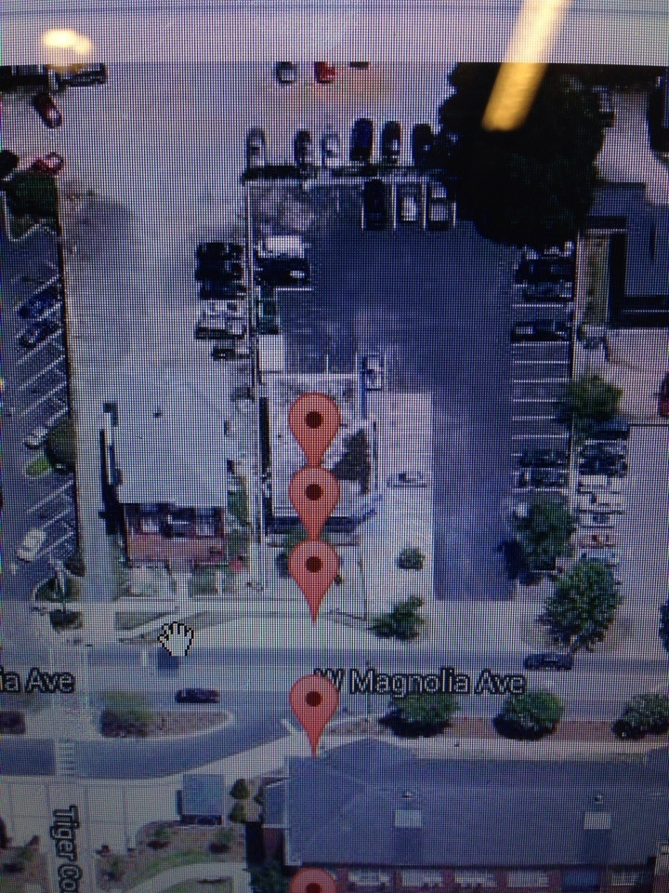

We have it working, that Steven going to dominos and it pushes to the website

Nathan Plotts

Cool! Steven walked in a pretty straight line though, what's up with that?

Thurs, 11:24am

Leo Da Lion

Is anyone gonna be in the lab today before class and stuff?

Thurs, 11:31am

Nathan Plotts

No, I'll be working from home though. We also, we need to split that deviceHub file so multiple people can work at once

Charles Baker

I'll be there around 2

Nathan Plotts

I'll do it around 12:30 unless someone else does it first

Thurs, 11:54am

Leo Da Lion

Yea move the functions that are related to the devices, like the sms connection move to the GPS class or make another manager class or something. And move the accepting of tcp connections and stuff to the laptop device file

Thurs, 12:03pm

Nathan Plotts

Ok, I'll do it as soon as I get home. If you're working on those files save and push your changes

Thurs, 12:12pm

Denney Burkholder

I can come at 315 if anyone will still be there

Thurs, 12:47pm

Leo Da Lion

I might be there 2:30 ish till 3:30 class

Thurs, 1:12pm

Nathan Plotts

Ok, I just pushed the split hub files. Main is still in deviceHub but you should do most work in the other files

Thurs, 1:49pm

Leo Da Lion

Main?

Nathan Plotts

Uhhhh, I mean the startdeviceserver

Thurs, 4:23pm

Nathan Plotts

Don't forget we have a meeting at 4:45

Thurs, 4:31pm

Charles Baker

I can't make it this week

Leo Da Lion

What time you guys wanna meet today those that can?

Steven Whaley

Whenever

Fri, 1:34pm

Charles Baker

I'm good to meet whenever for the rest of the day

Fri, 2:53pm

Leo Da Lion

Well in here now till whenever

Charles Baker

K, I'll head there soon

Fri, 3:13pm

Steven Whaley

Okay Ill come by when I can

Fri, 3:35pm

Denney Burkholder

Im going home tonight. I can keep work in the web pages there, is there anything else I can do? What is the meeting plan this weekend?

Fri, 4:55pm

Charles Baker

When are you coming by Steven?

1:53pm

Leo Da Lion

Where is y'all at

Nathan Plotts

I'm heading to Shelby in like 30 min. Are you there now?

Charles Baker

I can head there in a few minutes

Leo Da Lion

Yep

2:06pm

Nathan Plotts

Ok, just eating some food and then leaving. I got most of that request stiff down but I ran into a problem with turning a list into a byte array

3:15pm

Steven Whaley

Alright I'll head over in a few

5:30pm

Denney Burkholder

Back in auburn are yall still up there

Nathan Plotts

We'll be here all day

Denney Burkholder

Ok headin up